ZEROTH LEVEL DFD FOR TEMPLE MANAGEMENT SYSTEM

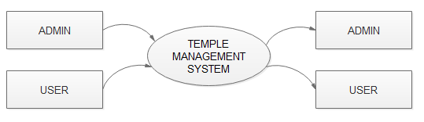

FIRST LEVEL DFD FOR ADMIN

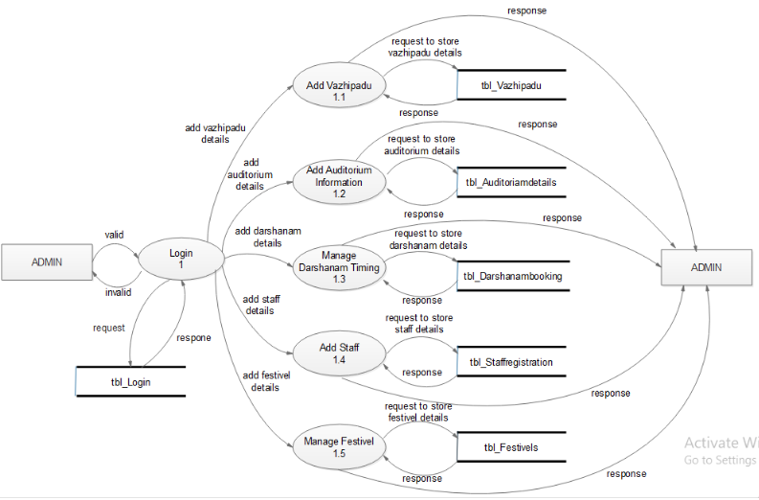

FIRST LEVEL DFD FOR USER

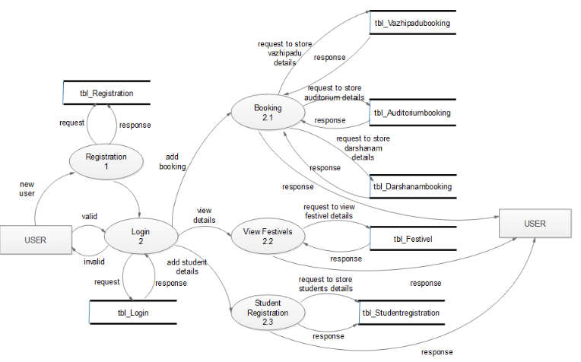

SECOND LEVEL DFD FOR USER

